**Team Details:**

* **Team Name:** Spectrum

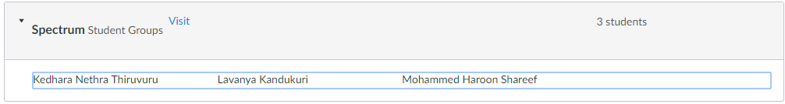

* **Resource Table:**

|  |  |  |
| --- | --- | --- |
| **Name** | **Sjsu ID** | **Email** |
| Kedhara Nethra Thiruvuru | 011833640 | Kedharanethra.thiruvuru@sjsu.edu |
| Mohammed Haroon Shareef |  | Mohammedharoon.shareef@sjsu.edu |
| Lavanya Kandukuri |  | Lavanya.kandukuri@sjsu.edu |

**Project Details:**

* **Project Idea:**
* **Project Type:**
* **Proposes Tasks:**
* **Dataset:**
* **Dataset Name:**
* **Dataset Size:**
* **Dataset Number of records:**